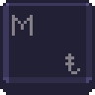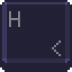

**MACROHARD**

Project Preview Demo

Team 1

ERYK CYGIELSKI

ANDREA BIALKOWSKI

NERMIN DEDOVIC

RANDY LY

JITEN PATEL

RAMEEZ ANWAR

DIMITRI VITYK

Link: <https://youtu.be/i-GkoQZExmI>